Comparative Study of the Performance of DenseNet201, ResNet50,and VGG16 Transfer Learning Models on Landsat-8 Satellite Imagery for Forest Classification

1st Arie Vatresia

*Informatics-Engineering Faculty University of Bengkulu* Bengkulu, Bengkulu [arie.vatresia@unib.ac.id](mailto:arie.vatresia@unib.ac.id)

2nd Kurnia Anggriani *Informatics-Engineering Faculty University of Bengkulu* Bengkulu, Bengkulu [kurnia.anggriani@unib.ac.id](mailto:kurnia.anggriani@unib.ac.id)

3rd Muhamad Rifqi Afriansyah *Informatics-Engineering Faculty University of Bengkulu*

Bengkulu, Bengkulu [rifqiaf7@gmail.com](mailto:rifqiaf7@gmail.com)

***Abstract*—Indonesia’s tropical forests, which cover 62.97% of its total land area, play a vital role in the global ecosystem. However, ongoing deforestation, particularly in Bengkulu Province, requires accurate monitoring. This study compares three transfer learning deep learning models—DenseNet201, ResNet50, and VGG16—for classifying forest and non-forest land cover using Landsat 8 satellite imagery. Landsat 8, with its Operational Land Imager (OLI) and Thermal Infrared Sensor (TIRS), provides spatial resolution data of 30 m, which is highly useful for monitoring land cover changes. The study focuses on the Taman Buru Semidang Bukit Kabu (SBK) in Bengkulu, a conservation forest that has been experiencing deforestation. The results show that DenseNet201 achieved the highest accuracy of 99.87%, followed by ResNet50 at 98.03% and VGG16 at 96.85%. Based on the analysis of forest area changes in Taman Buru Semidang Bukit Kabu, DenseNet201 proved to be more effective in detecting and classifying forest area changes between 2016 and 2020. For the original data, the detected forest area ranged from 7102.26 ha to 7684.65 ha, while for the enhanced data, it ranged from 7365.42 ha to 7741.35 ha. Although the other models performed well, DenseNet201 was superior in monitoring overall forest cover changes.**

***Index Terms*—forest, Landsat-8 satellite imagery, Densenet201,Resnet50, Vgg16, transfer learning, deep learning.**

1. Introduction

Indonesia’s tropical forests, which cover 62.97% of the total land area, play a vital role in the global ecosystem. These forests support a wide range of flora and fauna and function as a carbon sink, mitigating the impacts of climate change. However, the greatest threat to Indonesia’s forests is continuously increasing deforestation, one instance of which is in Bengkulu Province. Land conversion for agriculture, plantations, and settlements, often uncontrolled, has resulted in a drastic reduction in forest area [1].

In Bengkulu, one of the areas experiencing deforestation is the Semidang Bukit Kabu (SBK) Hunting Park, located across two regencies, Seluma and Central Bengkulu. Although this area is classified as a conservation forest, illegal activities such as rubber and palm oil plantations have affected the forest area in the region [2]. Ongoing land cover change threatens

the sustainability of the ecosystem and risks a decline in biodiversity [3].

To accurately monitor changes in forest area, more efficient and effective methods are needed compared to time-consuming and costly field surveys [4]. Remote sensing technology, particularly satellite imagery, offers a faster and broader alternative for detecting land cover changes. One technology that can support forest cover monitoring is the deep learning method, which allows for the automatic classification of satellite images with a high degree of accuracy. A very useful data source in this regard is Landsat 8 satellite imagery, which has a spatial resolution of 30 meters in its main bands and 15 meters in the panchromatic band, and is equipped with the Operational Land Imager (OLI) and Thermal Infrared Sensor (TIRS) that can detect land cover changes accurately and efficiently [5].

However, to achieve optimal results, deep learning models require training with large and high-quality datasets. Transfer learning, which utilizes pre-trained models on large datasets, can reduce the need for training data and speed up the training process. Various popular deep learning models such as DenseNet201, ResNet50, and VGG16 have proven effective in various image classification applications, including land cover classification.

Given this potential, this study aims to compare the perfor- mance of these three models in classifying Landsat-8 satellite imagery for forest and non-forest classification. Thus, this research is expected to make a significant contribution to the automated and more efficient monitoring of forest cover change in the Semidang Bukit Kabu Hunting Park, Bengkulu Province.

1. Materials and Methods
2. *Materials*
   1. Business Understanding

Land cover classification, particularly distinguishing between forest and non-forest, has become a crucial task in conservation and environmental management efforts. With technological advancements, especially in the fields of machine learning

and remote sensing, the process of land classification can be performed more quickly and efficiently using satellite imagery as input data. One effective approach is the application of deep learning methods through transfer learning, which allows the use of pre-trained models for new classification tasks even with limited training data. In this research, a comparative study of three transfer learning models—DenseNet201, ResNet50, and VGG16—was conducted to evaluate the performance of each in classifying Landsat-8 satellite images into forest and non-forest categories. The aim of this study is to determine the model that yields the best accuracy and is most effective in supporting forest monitoring and conservation through satellite image processing technology.

* 1. Data Understanding

The image dataset used in this study was classified into two main categories, namely forest and non-forest. The non-forest class includes various types of land cover such as rice fields, plantations, shrubs, open land, and settlements. The researchers used 500 images for each sample per class. The total number of samples used in the study amounted to 1000 images.

TABLE I: Number of Images Class

|  |  |  |
| --- | --- | --- |
| **No** | **Kelas** | **Jumlah** |
| 1 | Hutan | 500 |
| 2 | Non-Hutan | 500 |

The dataset in this study was obtained using QGIS software after a data preprocessing stage. Each image has a size of 300

× 300 pixels. The Landsat 8 imagery was downloaded via the Google Earth Engine platform, with the research area covering the Bengkulu Province region for the year 2020 and tested using previous research data from the Semidang Bukit Kabu Hunting Park, Seluma Regency, spanning the years 2016 to 2020.

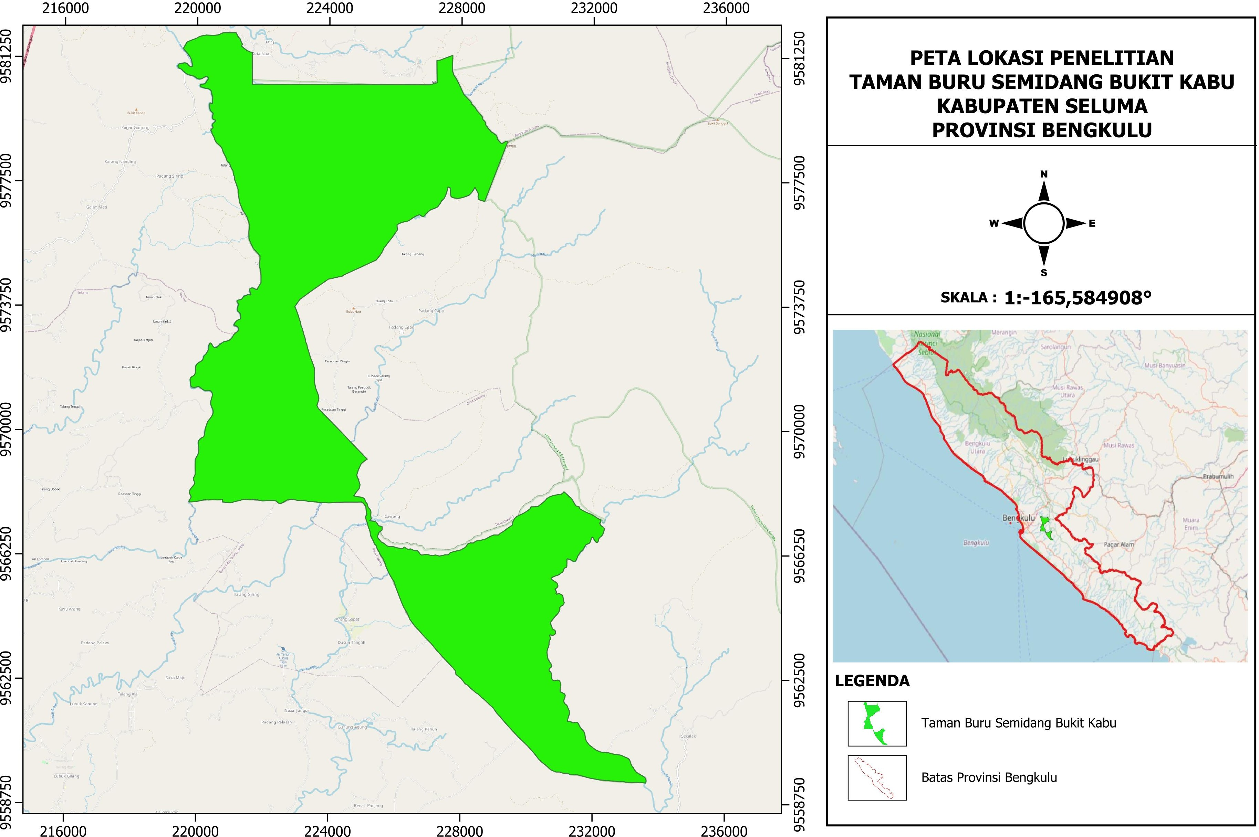

Fig. 1: Citra Taman Buru Semidang Bukit Kabu Kabupaten Seluma

* 1. Data Preparation

Data preparation is done by preprocessing satellite images, which aims to prepare images so that their spectral information can be analyzed more accurately and reduce the influence of atmospheric disturbances that might affect the analysis results. The stages carried out in this research are as follows:

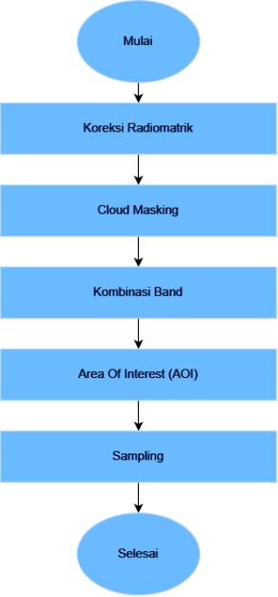

Fig. 2: Satellite Imagery Preprocessing flow

This stage includes radiometric correction, cloud masking, band combination, and determination of the area of interest (AOI). After that, a sampling process is carried out to prepare the training and test data that will be used in the transfer learning model.

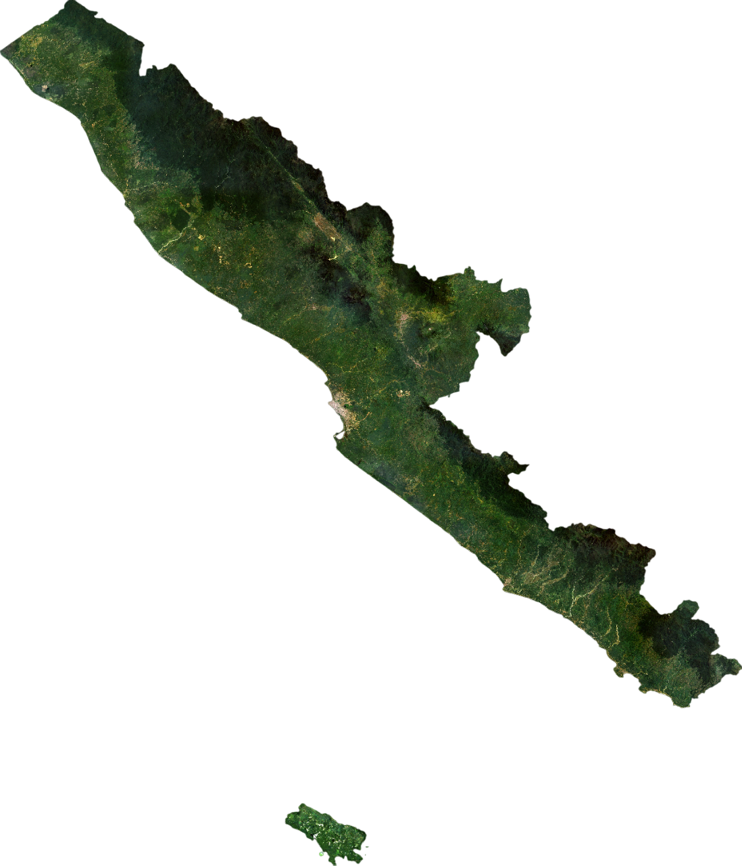

Fig. 3: Bengkulu Band 432

Fig 3 displays the area of Bengkulu Province that has been processed using composite band 432 and clipped according to the Area of Interest (AOI) based on the polygon shapefile (.shp) file of Bengkulu Province.

The pre-processing results were then visually interpreted and validated using official shapefiles from Geospatial Indonesia. This validation aims to ensure the accuracy of forest and non- forest class labeling. The forest class refers to areas covered by natural vegetation. Meanwhile, the non-forest class consists of several categories, namely: open land, settlements, gardens, shrubs, and paddy fields. A visual of each class is shown in Fig 4 below.

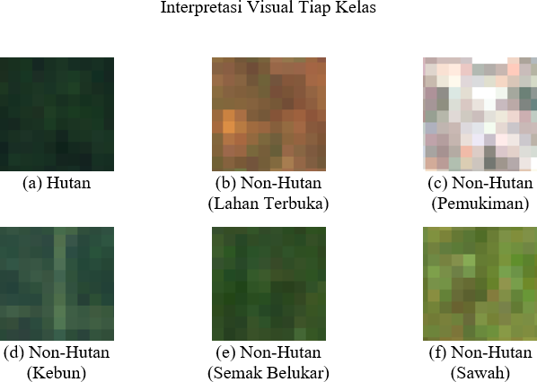 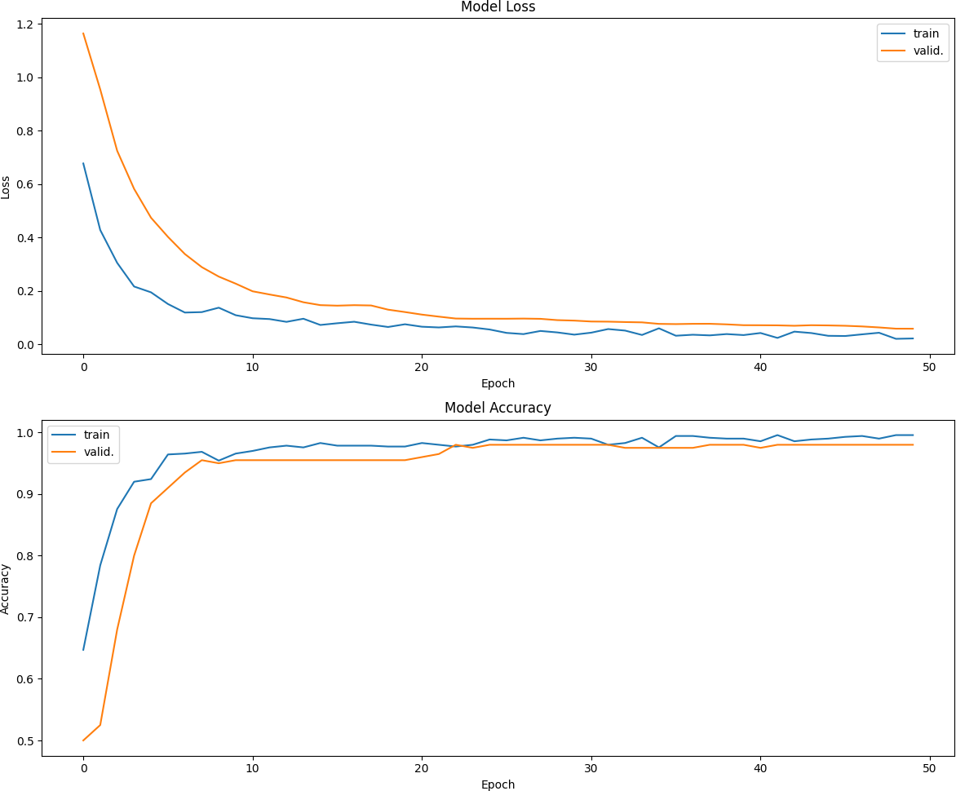

Fig. 4: Interpretasi Visual

The distribution of datasets in this study follows the ratio of 70:20:10 for each of the training, validation, and test data. All images used in this study have undergone a resizing process, where the initial image resolution of 300x300 pixels is reduced to 75x75 pixels to facilitate the training and evaluation process of the model.

1. *Methods*

Modeling :

Before starting the training process on each Transfer learning model, there are a number of training hyperparameters that must be determined first. The hyperparameter specifications used for this study are summarized in Table II:

TABLE II: Hyperparameter

|  |  |  |  |
| --- | --- | --- | --- |
| **Hyperparameter** | **DenseNet201** | **ResNet50** | **VGG16** |
| Batch Size | 64 | 64 | 64 |
| Optimizer | Adam | Adam | Adam |
| Loss Function | categorical  crossentropy | categorical  crossentropy | categorical  crossentropy |
| Learning Rate | 0.0001 | 0.0001 | 0.0001 |
| Epoch | 50 | 50 | 50 |

This study uses the same hyperparameters for training Trans- fer Learning models (DenseNet201, ResNet50, and VGG16) on Landsat-8 satellite image data for forest and non-forest classification. A batch size of 64 was chosen to balance computational efficiency and stability of weight updates. The Adam optimizer was chosen based on its advantages in training accuracy and efficiency. Categorical crossentropy loss function was used according to the output of the pre-training model and one-hot encoding label format. A learning rate of 0.0001 was chosen to avoid too large weight updates and ensure high accuracy. The number of epochs 50 was chosen as it provided the best accuracy and stability of the model, based on the self-test [6] [7] [8] [9].

1. Result and Discussion
2. *Evaluation*

The next step is to evaluate and visualize the models from DenseNet201, ResNet50, and VGG16.

* 1. DenseNet201

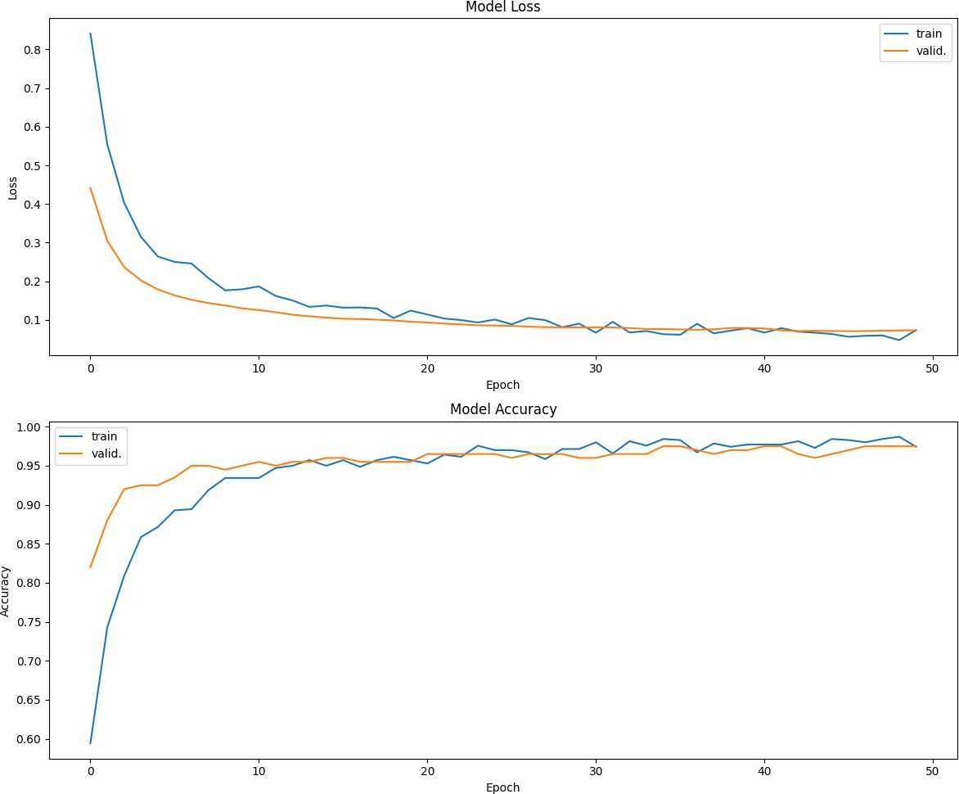

* 1. ResNet50

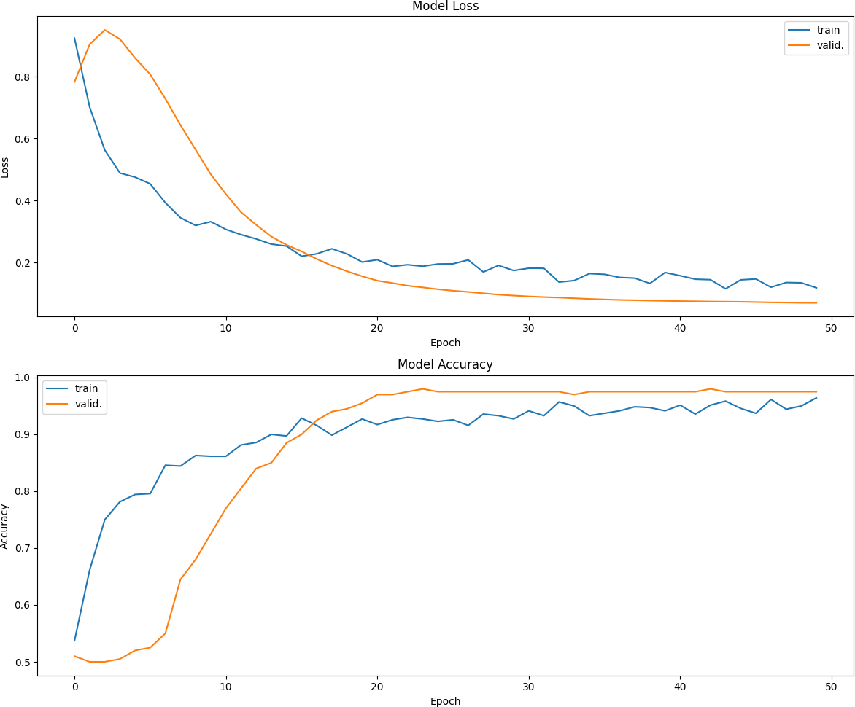

* 1. VGG16

Fig. 5: Training Graph (a) DenseNet201, (b) ResNet50, (c) VGG16

In Fig. 5, the loss & accuracy graphs for the models that have been trained for 50 epochs are shown. Model (a) DenseNet201 achieved an accuracy of 0.9987 (99.87%) with a loss value of 0.0196, and showed a validation accuracy of 0.9800 and a validation loss of 0.0591. The training time for this model was 3 minutes 16 seconds. Model (b) ResNet50 obtained an

accuracy of 0.9803 (98.03%) with a loss value of 0.07539, as well as a validation accuracy of 0.9800 and a validation loss of 0.0730. The training time for ResNet50 is 1 minute 58 seconds. Finally, model (c) VGG16 successfully achieved an accuracy of 0.9685 (96.85%) with a loss value of 0.1123, as well as a validation accuracy of 0.9750 and a validation loss of 0.07598. The training time for VGG16 was 1 minute 36 seconds. All these results can be seen in the graph shown in the figure.

Next is the performance model stage. The performance of the model that has been trained is displayed by displaying a confusion matrix that shows the performance of the model. The number contained in Fig. 6 shows the number of images that are successfully predicted according to the training data.

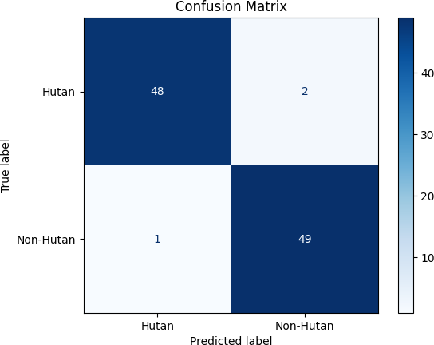

1. DenseNet201

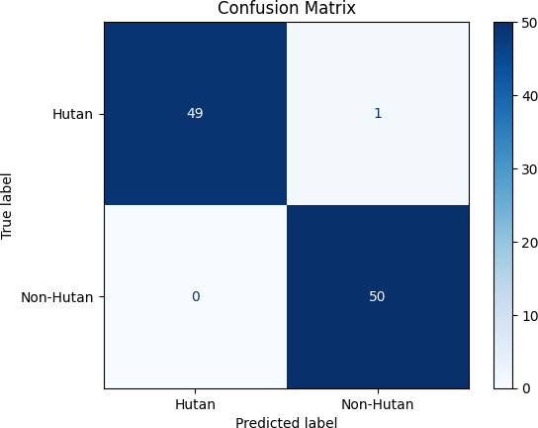

1. ResNet50

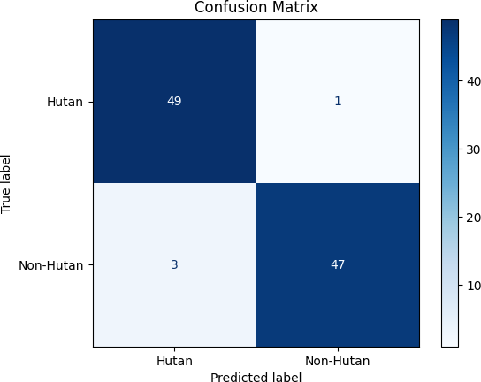

1. VGG16

Fig. 6: Confusion Matrix (a) DenseNet201, (b) ResNet50, (c) VGG16

In Fig. 6, the confusion matrix evaluation of model (a) DenseNet201 shows that the model successfully classified 48 forest images and 49 non-forest images with very low errors, only 2 forest images were incorrectly predicted as non-forest and 1 non-forest image as forest. This error can be explained by inter-class similarity and intra-class variation. Model (b) ResNet50 showed high accuracy with 49 forest images correctly predicted and only 1 error (False Positive) in classifying forest images as non-forest, with no errors in identifying non-forest images. Model (c) VGG16 also performed well albeit with a higher error rate, especially in the non-forest class with 3 False Positive errors, but was still effective with 49 forest images and 47 non-forest images correctly predicted.

1. *Classification Visualization*

Visualization of land cover classification using validation data of Semidang Bukit Kabu Hunting Park area, Seluma Regency, which provides an overview of the distribution of land cover types in the area based on satellite image classification results. The validation data used in this analysis comes from previous research that has been conducted by other researchers at the same location, which includes the original data and data that has been enhanced 4 times. The visualization was conducted using three models, DenseNet201, ResNet50 and VGG16, which have been trained to identify forest and non-forest land cover. The following are the results of raster classification using the original data and data that has been enhanced 4x from the Semidang Bukit Kabu Hunting Park area using three Transfer learning models namely: DenseNet201, ResNet50, and VGG16 in a span of 5 years. In addition, there are also previous research data used for validation of the three models presented in Table III:

TABLE III: Forest and Non-forest Classification Results of Each Model Using Original and Enhanced Data

|  |  |  |  |  |
| --- | --- | --- | --- | --- |
| **Tahun** | **Densenet201** | **Resnet50** | **VGG16** | **Validasi** |
| 2016 |  |  |  |  |
| 2016 (4X) |  |  |  |  |
| 2017 |  |  |  |  |
| 2017 (4X) |  |  |  |  |
| 2018 |  |  |  |  |
| 2018 (4X) |  |  |  |  |
| 2019 |  |  |  |  |
| 2019 (4X) |  |  |  |  |
| 2020 |  |  |  |  |
| 2020 (4X) |  |  |  |  |

Based on Table III, the three models show different classi- fication patterns. DenseNet201 performed best with smooth, accurate classification and clear boundaries between forest and non-forest, and validation results that were closest to previous research data. ResNet50, although slightly inferior, still provided stable and accurate results, but the boundary between the two classes was not as sharp as DenseNet201. VGG16 produced a coarser classification, with blurred boundaries and validation results that were further away from the previous study data. Overall, DenseNet201 excelled in classification clarity and accuracy, followed by ResNet50 and VGG16 which were less accurate.

1. *Comparison of forest area (ha) of each model with previous research data*

After the raster classification is complete, the data will be processed using QGIS by utilizing the unique value palette to count the number of pixels in each classified class. The number of pixels is then multiplied by the Landsat 8 30x30 meter pixel dimension and divided by 10,000 to obtain the land cover area in hectares (ha). This calculation was carried out from 2016 to 2020, and the results are presented in Table IV and Table V :

TABLE IV: Forest Area Original Data Semidang Bukit Kabu Hunting Park

|  |  |  |  |  |  |
| --- | --- | --- | --- | --- | --- |
|  | **2016** | **2017** | **2018** | **2019** | **2020** |
| **Densenet201** | 7517,07  (-3,13%) | 7684,65  (0,04%) | 7443,00  (1,05%) | 7102,26  (2,04%) | 7110,72  (-0,46%) |
| Resnet50 | 7500,69  (-3,34%) | 7454,70  (-2,95%) | 7135,74  (-3,12%) | 6355,89  (-8,69%) | 7160,85  (0,24%) |
| VGG16 | 7173,36  (-7,56%) | 6848,73  (-10,84%) | 7232,22  (-1,81%) | 7082,55  (1,75%) | 7080,48  (-0,89%) |
| Data Penelitian  Sebelumnya | 7760,16 | 7681,32 | 7365,51 | 6960,51 | 7143,93 |

TABLE V: Forest Area Data Increased in Semidang Bukit Kabu Hunting Park

|  |  |  |  |  |  |
| --- | --- | --- | --- | --- | --- |
|  | **2016** | **2017** | **2018** | **2019** | **2020** |
| **Densenet201** | 7741,35  (1,64%) | 7630,11  (0,33%) | 7365,42  (-3,49%) | 7528,23  (-0,29%) | 7716,69  (-0,21%) |
| Resnet50 | 8021,07  (5,32%) | 7981,92  (4,96%) | 7778,25  (1,92%) | 7090,38  (-6,08%) | 7687,26  (-0,59%) |
| VGG16 | 8042,31  (5,59%) | 7744,50  (1,83%) | 8112,33  (6,30%) | 7948,71  (5,28%) | 7946,37  (2,76%) |
| Data Penelitian  Sebelumnya | 7616,21 | 7604,96 | 7631,39 | 7549,76 | 7732,92 |

Based on the comparative analysis of the two validation datasets, the Densenet201 model consistently showed the most superior performance as it was able to produce forest area predictions that were closest to the reference data. In the comparison with “Previous Research Data” (Table IV), Densenet201 displays remarkable accuracy with minimal differences, such as in 2017 (+0.04%) and 2020 (-0.46%). This is in stark contrast to Resnet50 and VGG16, which show significant fluctuations and much larger errors, e.g. VGG16 with a deviation of -10.84% in 2017 and Resnet50 with a deviation of -8.69% in 2019. The superiority of Densenet201 is again

evident when tested with “Enhanced Data” (Table V), where the model again recorded the smallest differences in 2017 (+0.33%), 2019 (-0.29%), and 2020 (-0.21%). Meanwhile, Resnet50 and VGG16 tend to produce values that are significantly different from the benchmark data, either in the form of overestimates (such as VGG16 at +6.30% in 2018) or underestimates (such as Resnet50 at -6.08% in 2019). Thus, it can be concluded that Densenet201 is the most reliable and accurate model among the three.

1. Conclusion

The conclusion of this study shows that the three evaluated architectures—DenseNet201, ResNet50, and VGG16—proved effective for the task of forest and non-forest land cover classification using remote sensing data. Although all demon- strated high performance, DenseNet201 achieved the most superior results with an accuracy of 99.87%. It was followed by ResNet50 with 98.03% and VGG16 with 96.85%. Overall, the performance of these models in classifying forest and non- forest areas also revealed that DenseNet201 was superior. This model could detect forest and non-forest areas well. While ResNet50 and VGG16 also provided fairly good results, neither was as accurate as DenseNet201 in classifying remote sensing imagery.

Based on the analysis of forest area change in the Semidang Bukit Kabu Hunting Park, the DenseNet201 model showed better and more consistent results in detecting the extent of forest cover between 2016 and 2020. The forest area detected by DenseNet201 on the original data was 7517.07 ha in 2016 (-3.13%), 7684.65 ha in 2017 (0.04%), 7443.00 ha in 2018

(1.05%), 7102.26 ha in 2019 (2.04%), and 7110.72 ha in 2020

(-0.46%). For the enhanced data, the detected forest area was 7741.35 ha in 2016 (1.64%), 7630.11 ha in 2017 (0.33%),

7365.42 ha in 2018 (-3.49%), 7528.23 ha in 2019 (-0.29%),

and 7716.69 ha in 2020 (-0.21%). Although other models like ResNet50 and VGG16 provided good results, DenseNet201 remained more effective in classifying the overall changes in forest area during that period.

References

1. C. Nakita and F. U. Najicha, “Pengaruh deforestasi dan upaya menjaga kelestarian hutan di indonesia,” *Ius Civile: Refleksi Penegakan Hukum Dan Keadilan*, vol. 6, no. 1, p. 92, 2022.
2. N. Jainuddin, “Dampak deforestasi terhadap keanekaragaman hayati dan ekosistem,” *Jurnal Humaniora, Sosial Dan Bisnis*, vol. 1, no. 2, pp. 131– 140, 2023.
3. M. Dede, C. Asdak, and I. Setiawan, “Spatial dynamics model of land use and land cover changes: A comparison of ca, ann, and ann-ca,” *Register: Jurnal Ilmiah Teknologi Sistem Informasi*, vol. 8, no. 1, pp. 38–49, 2022.
4. S. Mahmasani, “View metadata, citation and similar papers at core.ac.uk,”

*Core*, pp. 274–282, 2020.

1. N. A. Lestari, I. Ridwan, and F. Fahruddin, “Identifikasi penggunaan lahan menggunakan metode klasifikasi maksimum likelihood pada citra satelit landsat 8 oli/tirs di kabupaten lamandau provinsi kalimantan selatan tengah,” *Jurnal Natural Scientiae*, vol. 1, no. 1, pp. 29–34, 2021.
2. R. Naushad, T. Kaur, and E. Ghaderpour, “Deep transfer learning for land use and land cover classification: A comparative study,” *Sensors*, vol. 21, no. 23, pp. 1–13, 2021.
3. D. Anggara, N. Suarna, and Y. Arie Wijaya, “Performance comparison analysis of optimizer adam, sgd, and rmsprop on the h5 model,” *Jurnal Ilmiah NERO*, vol. 8, no. 1, 2023. [Online]. Available: [https://www.kaggle.com/datasets/jonathanoheix/face-expression-](http://www.kaggle.com/datasets/jonathanoheix/face-expression-) recognition-dataset
4. Q. A. Fitroh and S. ’Uyun, “Deep transfer learning untuk meningkatkan akurasi klasifikasi pada citra dermoskopi kanker kulit,” *Jurnal Nasional Teknik Elektro Dan Teknologi Informasi*, vol. 12, no. 2, pp. 78–84, 2023.
5. M. Khoiruddin, A. Junaidi, and W. A. Saputra, “Klasifikasi penyakit daun padi menggunakan convolutional neural network,” *Journal of Dinda: Data Science, Information Technology, and Data Analytics*, vol. 2, no. 1, pp. 37–45, 2022.